[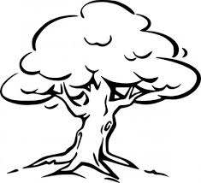](http://www.google.com.au/url?sa=i&rct=j&q=&esrc=s&source=images&cd=&cad=rja&uact=8&docid=Q-jachXC6K5l9M&tbnid=dEZcnnM6t4ztbM:&ved=0CAUQjRw&url=http://all-free-download.com/free-vector/vector-clip-art/tree_outline_clip_art_11785.html&ei=gkD1U_q5CIzp8AXO4oLQAQ&bvm=bv.73231344,d.dGc&psig=AFQjCNFOn96papxJpTkYcyqtzYCWu8mjvQ&ust=1408668120729314)Chemical and Investigating Science Year 7

Mid Topic Test

Name: _______________________________________ Total: 69 marks

Part A: Multiple-Choice (10 marks)

1. Which of the following are **all** correct?

**A** Chemistry – Science of materials, Geology – Science of rocks, Psychology- Science of forces.

**B** Ecology – Science of the environment, Astronomy – Science of the universe, Chemistry – Science of materials.

**C** Biology – Science of living things, Ecology – Science of plants and animals, Geology – Science of rocks.

**D** Physics – Science of forces, Astronomy – Science of asteroids, Ecology – Science of the environment.

2. Which of the following lists contains only measuring equipment?

**A** a beaker, a graduated cylinder, a conical flask and an electronic scale.

**B** a measuring cylinder, a test-tube, a conical flask and a spatula.

**C** a beaker, a graduated cylinder, a test-tube and a filter funnel.

**D** a measuring cylinder, a evaporating basin, a beaker and a conical flask.

3.Which of the following is **not** a safety rule in a Science laboratory?

**A** do not run or push.

**B** always wear safety glasses when using chemicals.

**C** do not eat, taste, drink or sniff anything unless told to by a teacher.

**D** if you break something immediately get rid of it.

4. Which of the following is **not** a mixture?

**A** air.

**B** seawater.

**C** paint.

**D** all of them are mixtures.

5. A solvent is:

**A** a substance that does not dissolve.

**B** the substance that dissolves.

**C** the substance that dissolves the other one.

**D** when a substance dissolves in another, forming a clear mixture.

6. Which of the following are **all** ways to separate an insoluble substance from a liquid?

**A** decantation, filtration, sieving and gravity separation.

**B** distillation , decantation, filtration and gravity separation.

**C** gravity separation, evaporation, filtration and chromatography.

**D** evaporation, distillation, filtration and decantation.

7. Which one of the following is soluble in water?

**A** sand.

**B** salt.

**C** oil.

**D** iron filings.

8. Which of the following is an inference?

**A** everyone is packing up.

**B** it must be nearly home time.

**C** the bell will go soon.

**D** the time is 3.01pm.

9. Which of the abbreviations for the units are all correct?

**A** gram – g, litre – L, kilogram – kg, millimetre – mm, minutes – min.

**B** gram – gm, litre – L, kilogram – kg, millimetre – mm, minutes – min.

**C** gram – g, litre – l, kilogram – kg, millimetre – ml, minutes – min.

**D** gram – g, litre – L, kilogram – kgm, millimetre – mm, minutes – mins.

10. Which graph would you use for a set of continuous data, such as time and temperature?

**A** column or bar.

**B** pie.

**C** line.

**D** none of the above.

**Part 2: Short Answer**

1. **Match** the following terms with their correct meaning. Note: not all words will be used.

Bunsen burner, inference, observation, prediction, meniscus, independent variable, dependent variable, aim, method, results, soluble, insoluble, solution, dissolve, saturated, concentrated, dilute, filter, measuring cylinder, beaker, solvent, solute, decantation, filtration

a) Can be dissolved _________________________________________________________

b) The thing you measure in an experiment _______________________________________

c) What you are trying to do in an experiment _____________________________________

d) The separation of an insoluble substance by pouring it off _________________________

e) A glass tube used to measure liquids accurately __________________________________

f) The curved surface of liquids ________________________________________________

g) The substance being dissolved _______________________________________________

h) A logical explanation for what you see _________________________________________

i) Tells how to do an experiment _______________________________________________

j) A lot of solute in the solvent _________________________________________________

(10 marks)

2. **Draw** and **label** a scientific diagram of a Bunsen being used to heat water in a beaker:

(5 marks)

3. a) **Describe** what happens to the particles when sugar is put in water and stirred:

___________________________________________________________________________

___________________________________________________________________________

___________________________________________________________________________

___________________________________________________________________________

(2 marks)

b) **Describe** what the solution looks like after a short time:

___________________________________________________________________________

___________________________________________________________________________

___________________________________________________________________________

(2 marks)

4. a) **List** your five senses ____________________________________________________

1. **List** three observations you could make about a burning candle __________________

_____________________________________________________________________

_____________________________________________________________________

1. **List** 4 rules you should follow in a Science laboratory _________________________

_____________________________________________________________________

_____________________________________________________________________

(4 marks)

5. **Justify** the following statement: *When salt dissolves in water it is still in the solution, it has not gone away***.**

___________________________________________________________________________

___________________________________________________________________________

___________________________________________________________________________

(2 marks)

6. **Explain** the meaning of *dilute solution*: __________________________________________

___________________________________________________________________________

___________________________________________________________________________

(2 marks)

7. **Classify** the following as solute, solvent or solution:

1. Water __________________________________________________
2. Salt ____________________________________________________
3. Coke __________________________________________________
4. Sugar __________________________________________________

(4 marks)

8. **Identify** the method of separation that could be used for the following situations:

1. You want some fine clean sand without any sticks or stones from the soil in your garden ___________________________________
2. You drop some iron nails into some sand in your backyard _________________________
3. You want to see if the soil in a river has gold in it ________________________________
4. Some sand has got into your bucket of water ____________________________________
5. The lettuce for your salad has water all through it ________________________________

(5 marks)

9. The following table show the solubility of different substances in g/100mL water at 100oC.

|  |  |
| --- | --- |
| **Solute** | **g/mL in 100mL water at 100oC** |
| Salt | 39 |
| Sugar | 487 |
| Copper sulphate | 77 |
| Alum | 165 |
| Potassium dichromate | 81 |

a) Graph the results above as a column graph. (5 marks)

b) Whichsolute is most soluble? ___________________________________________

(1 mark)

c) Which solute is least soluble? ____________________________________________

(1 mark)

d) **Compare** the solubility of alum and potassium dichromate _____________________

___________________________________________________________________________

___________________________________________________________________________

(2 marks)

e) **Estimate** what the solubility of sugar would be at 50oC________________________

(1 mark)

f) **Explain** why the above estimate may not necessarily be accurate ________________

___________________________________________________________________________

___________________________________________________________________________

___________________________________________________________________________

___________________________________________________________________________

(2 mark)

10. **Define** the following:

i) Mixture _____________________________________________________________

___________________________________________________________________________

ii) Independent variable ___________________________________________________

___________________________________________________________________________

iii) Insoluble _____________________________________________________________

___________________________________________________________________________

iv) Experiment ___________________________________________________________

___________________________________________________________________________

(4 marks)

11. **State** the amount in each graduated cylinder (the first one is done for you)

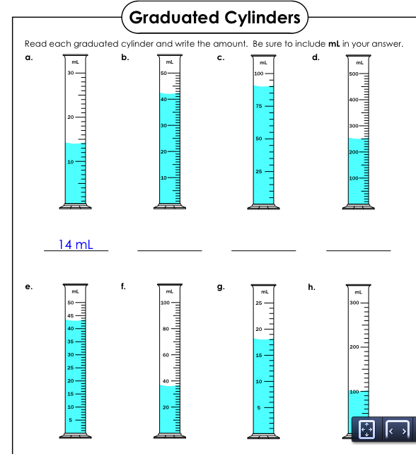

(7 marks)